
RESULT OF CLUB MEMBERS SELECTION
The Student Council is pleased to announce the results of the Club’s Members Selection for the Academic Session 2026–27. The selection has been carried out through a comprehensive evaluation process comprising application screening and personal interviews conducted by the respective interview panels.
The following students have been selected as Captains, Vice Captains and Members for their respective clubs:
SHADOW CODE SOCIETY Members List | Academic Session 2026-27
S. No. | Student Name | Branch | Year | Designation
1 | ADITYA KUMAWAT | CYS | 3 | Captain
2 | NAKSHTRA PAL PARIHAR | AI/ML | 3 | Vice-Captain
3 | PRAMOD PATEL | CYS | 3 | Member
4 | NISHANT RANKAWAT | CYS | 3 | Member
5 | NIKHIL ADWANI | AI/ML | 3 | Member
6 | LAKSHAY JAIN | CYS | 3 | Member
7 | VAIBHAV PANWAR | AI/ML | 3 | Member
8 | KOMAL SAYAL | AI/ML | 3 | Member
9 | RAJSHREE SOLANKI | CYS | 2 | Member
10 | LAKSHAY VYAS | CYS | 3 | Member
11 | YASH KUMAR | AI/ML | 2 | Member
12 | AZEEM | AI/ML | 2 | Member
13 | FARDEEN KHAN | AI/ML | 2 | Member
14 | AKHILEH SHARMA | AI/ML | 2 | Member
15 | JAIDEEP VAISHNAV | AI/ML | 2 | Member
16 | KRATIKA SINGH | AI/ML | 2 | Member

Note: The appointment of all selected Club Captains, Vice Captains and Members is subject to adherence to the institute's rules and code of conduct. Any misconduct, malicious, or unauthorized activity will result in immediate revocation from the post.

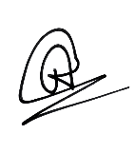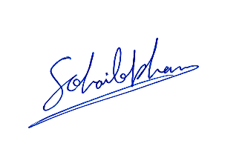
ADITYA KUMAWAT SOHAIB KHAN
Academic Session 2026-27 Faculty Mentor, Shadow Code Society

